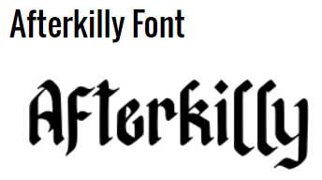

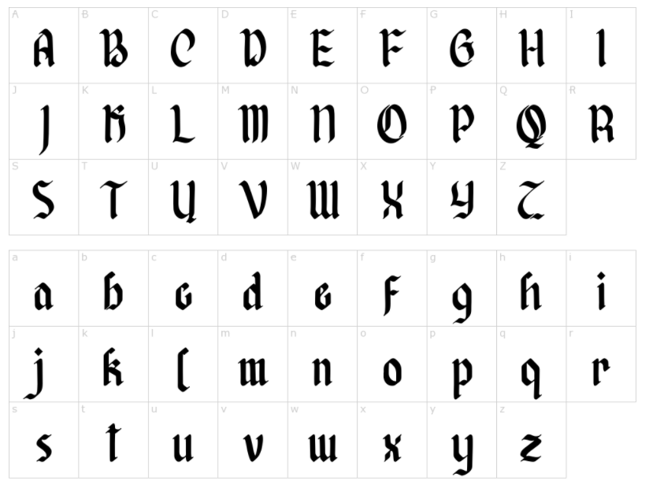

<https://fontmeme.com/fonts/afterkilly-font/>

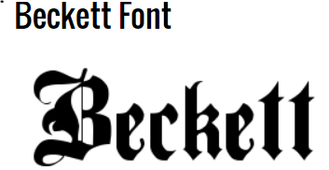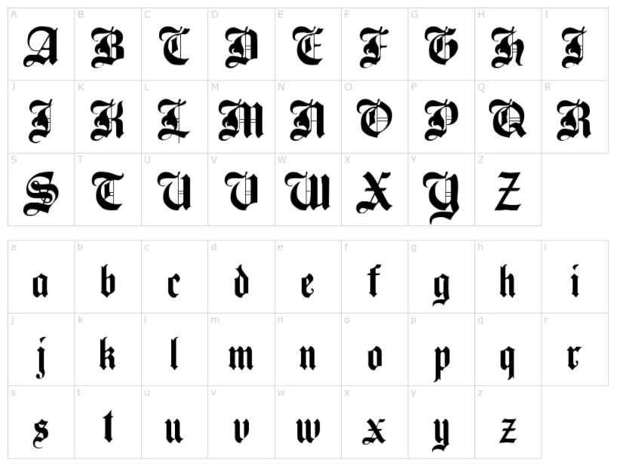

<https://fontmeme.com/fonts/beckett-font/>

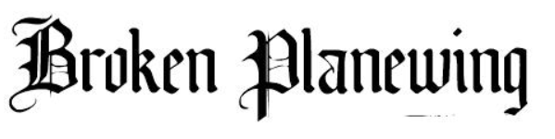

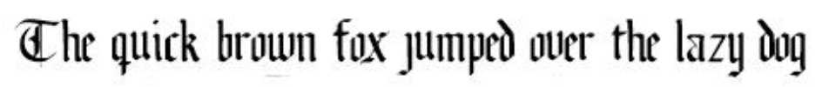

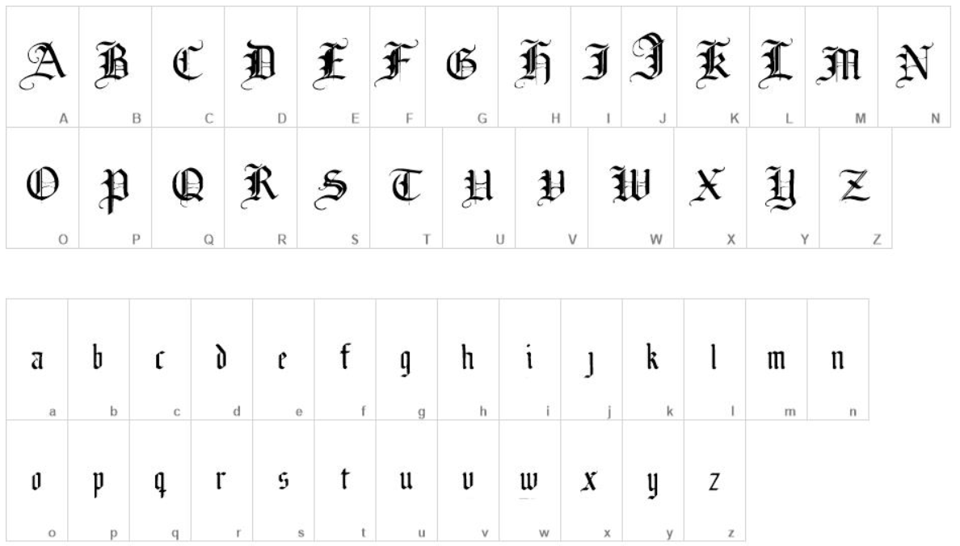

<https://www.freebestfonts.com/broken-planewing-font>

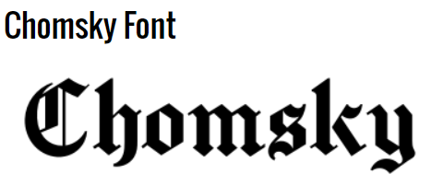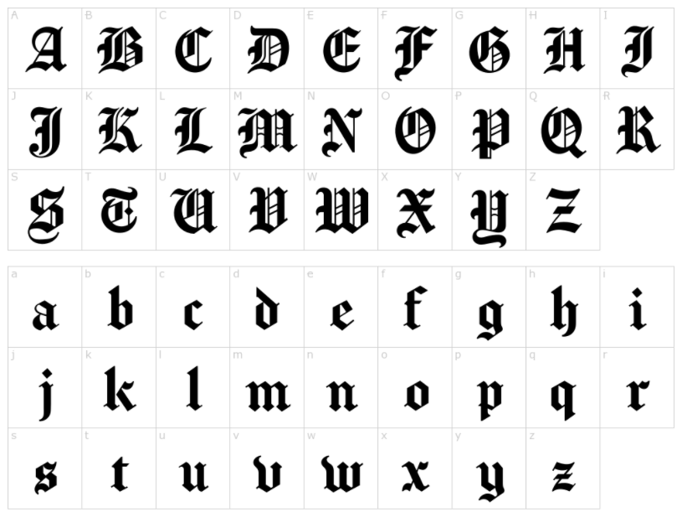

<https://fontmeme.com/fonts/chomsky-font/>

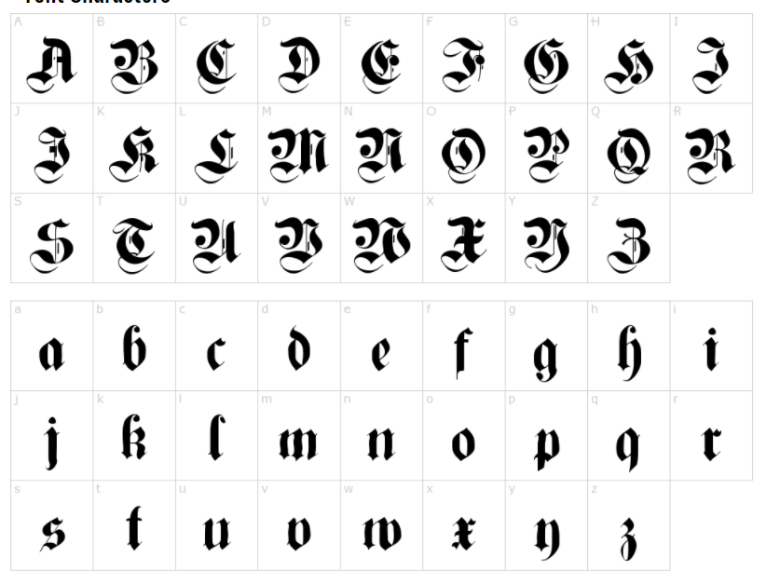

<https://fontmeme.com/fonts/cuxhaven-times-font/>

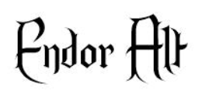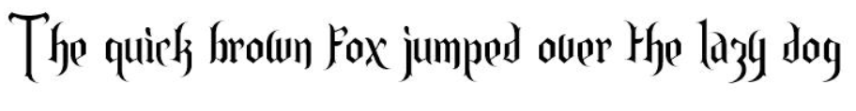

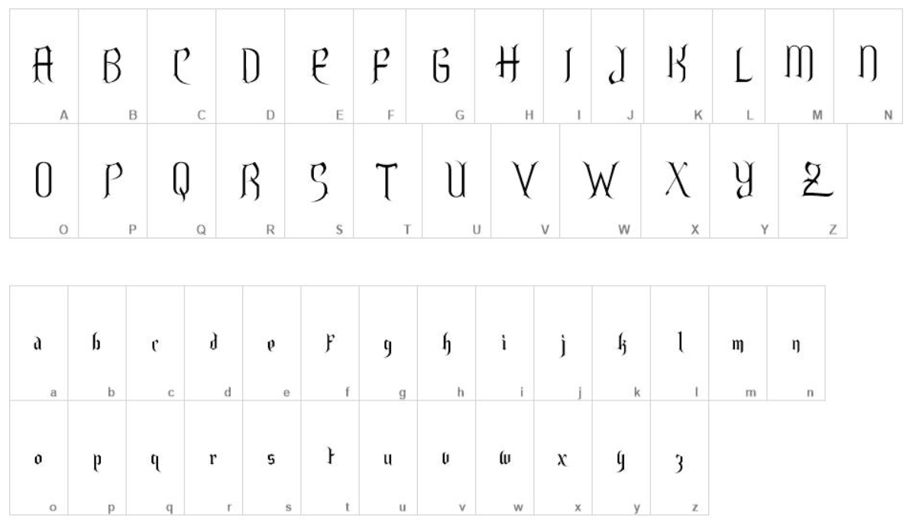

<https://www.freebestfonts.com/endor-font>

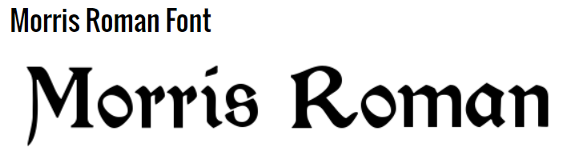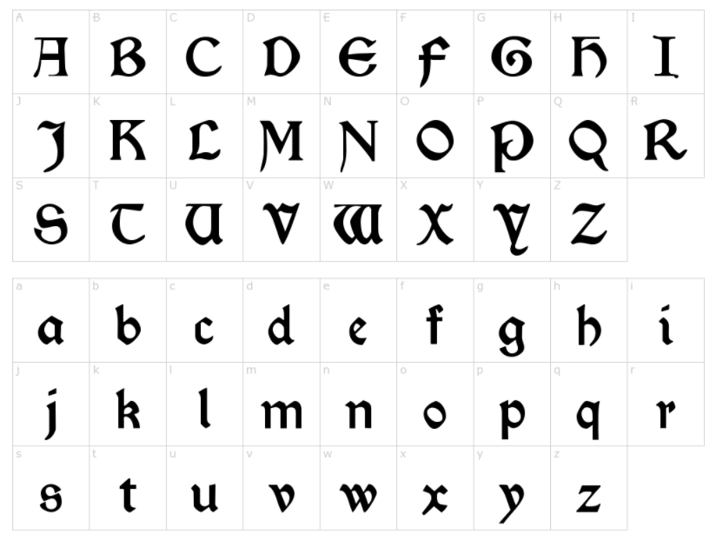

<https://fontmeme.com/fonts/morris-roman-font/>

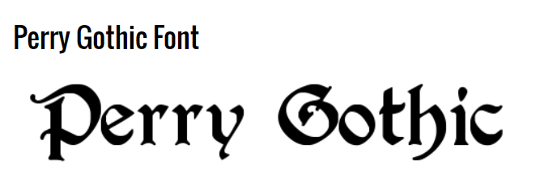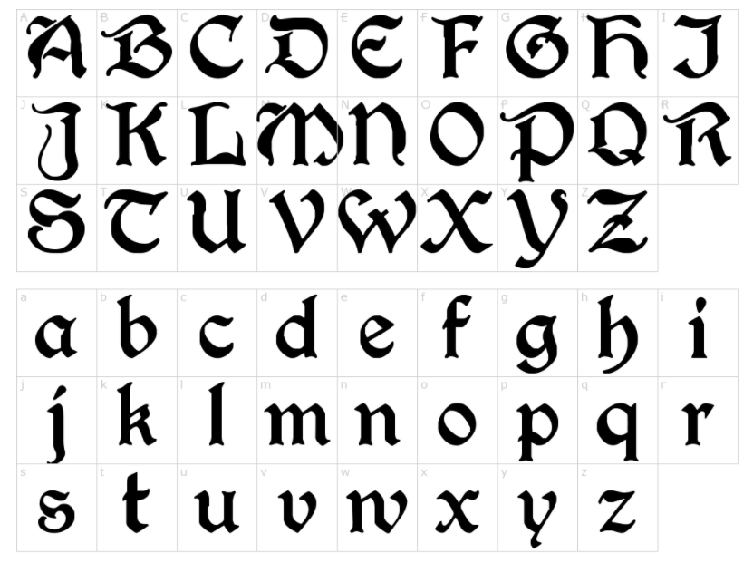

<https://fontmeme.com/fonts/perry-gothic-font/>